H.T No
Regulations:
A18

Sreenidhi Institute of Science and Technology
(An Autonomous Institution)
Code No: 7AC07 Date: 14-July-2023 (FN)

B.Tech III-Year I- Semester External Examination, July - 2023 (Supplementary)
CONTROL SYSTEMS (ECE)

Time: 3 Hours Max.Marks:70

Note: a) No additional answer sheets will be provided.
b) All sub-parts of a question must be answered at one place only, otherwise it will not be valued.
c) Missing data can be assumed suitably.
Bloom's Cognitive Levels of Learning (BCLL)

Remember | L1 | Apply | L3 | Evaluate | L5
Understand | L2 | Analyze | L4 | Create | L6

Part - A Max.Marks:20

Answer all QUESTIONS.

 |  | BCLL | CO(s) | Marks
1 | List the advantages of synchro’s. | L1 | CO1 | [2M]
2 | List the various types of standard test signals. | L1 | CO2 | [2M]
3 | What is break-away and break-in point? | L1 | CO3 | [2M]
4 | Given ζ (zeta)=0.7 and w_{n}=10 rad/sec find the resonant peak, resonant frequency. | L2 | CO4 | [2M]
5 | Draw the polar plot of G(s)=1/(Ts+1). | L2 | CO5 | [2M]
6 | Define state variable. | L1 | CO6 | [2M]
7 | List out the limitations of open loop systems over closed loop systems. | L1 | CO1 | [2M]
8 | Define stable system. | L1 | CO3 | [2M]
9 | When lag/lead/lag-lead compensation is employed? | L1 | CO5 | [2M]
10 | Distinguish between open loop and closed loop system. | L2 | CO1 | [2M]

Part – B Max.Marks:50
ANSWER ANY FIVE QUESTIONS. EACH QUESTION CARRIES 10 MARKS.

 |  |  | BCLL | CO(s) | Marks
11. | a) | Explain the effects of feedback in control systems. | L2 | CO1 | [5M]
 | b) | Determine C/R for the system represented by the block diagram shown in Fig  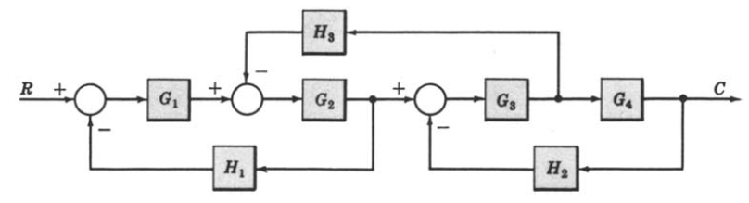 | L3 | CO1 | [5M]
12. | a) | Obtain the unit ramp response of a unity feedback system, whose open loop transfer function is G(s)=5/s(s+4) | L2 | CO2 | [5M]
 | b) | The open loop transfer function of a unity feedback system is given by G(s)=K/s(Ts+1), Where K and T are constants. By what factor should the amplifier gain be reduced so that the peak overshoot of unit step response of the system is reduced from 75% to 25%? | L5 | CO2 | [5M]
13. | a) | Use the routh stability criterion to determine the location or roots on the s-plane and hence the stability for the system represented by the characteristic equation s⁶+s⁵+3s⁴+3s³+3s²+2s+1=0. | L3 | CO3 | [5M]
 | b) | The open loop transfer function of a unity feedback system is given by G(s)=K(s+4)/s(s²+7s+16). Sketch the root locus of the system. | L3 | CO3 | [5M]
14. | a) | For the following transfer function draw bode plot and obtain gain cross over frequency.  G(s)=20/s(1+3s)(1+4s) | L3 | CO4 | [5M]
 | b) | Explain why it is important to conduct frequency domain analysis of linear control systems. | L2 | CO4 | [5M]
15. | a) | Consider a unity feedback system having an open loop transfer function G(s)=K/s(1+0.5s)(1+4s). Sketch the polar plot and determine the value of K so that (i) Gain margin is 20 db (ii) Phase margin is 30⁰. | L5 | CO5 | [5M]
 | b) | Discuss lead, lag compensator? | L2 | CO5 | [5M]
16. | a) | Diagonalization the system matrix  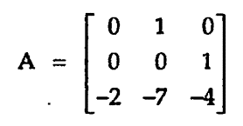 | L2 | CO6 | [5M]
 | b) | Determine the Controllability and Observability of a state model.  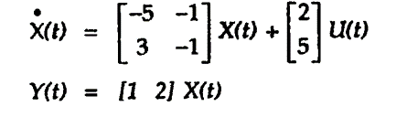 | L3 | CO6 | [5M]
17. | a) | What are the differences between block diagram reduction and signal flow graph reduction? | L2 | CO1 | [4M]
 | b) | Discuss the effects of proportional integral controller on the performance of the system. | L2 | CO2 | [3M]
 | c) | List the steps of construction the root locus. | L1 | CO3 | [3M]
18. | a) | Define Gain margin, phase margin and bandwidth. | L1 | CO4 | [4M]
 | b) | Explain about Nyquist plot. | L2 | CO5 | [3M]
 | c) | Write the properties of state transition matrix. | L2 | CO6 | [3M]

-- 00 -- 00 –

